HELLENIC REPUBLIC
MINISTRY OF ECONOMY & DEVELOPMENT

Specification of Budget Costs
Project Beneficiaries’ Guidebook

INTERREG IPA CBC:
GREECE – ALBANIA 2014-2020
CCI 2014TC16I5CB010

Version 1.0
August 2018

Table of Contents
1. Introduction 3
2. Specification of the Budget Costs Excel File Structure 4
2.1 General 4
2.2 “Cover page” 4
2.3 “Beneficiaries’ section” 5
2.4 “Summary Tables” 13
3. Printing the SoBC 14
4. Uploading the SoBC on the MIS 14

Introduction
The main scope of the “Specification of Budget Costs” (SoBC) excel template is twofold:
- To provide a common tool to all project proposals for building the budget and
- To assist the partnerships in providing all the necessary details required by the JS
for the budget evaluation.

The SoBC generates the budget tables that are needed in the Application Form and it is designed to support the beneficiaries to work in a single file and just transfer the result of the calculations.

As the SoBC excel file has a restricted number of characters in the respective descriptive sections of the expenditures, the Applicants are free to submit any other supporting documents that can justify their costs. These can be detailed breakdown of infrastructure budget analysis, pricelists from possible providers, offers, Salary sheets, etc. In any case, the
JS reserves the right to request additional information regarding specific budget lines and items, in case the description provided does not give sufficient justification.

Finally, it must be noted that in all cases and in all Budget Lines, the provisions, budget limits and eligibility criteria of the Regulations IPA II regulation 231/2014, (CIR) 236/2014, IPA II Implementing Regulation 447/2014, as well as the budget limits of the Calls, need to be applied and followed.

Note:
In case of any discrepancy between the two documents i) the Application Form and ii) the Specification of Budget Costs, the budget of the Application form will be considered the one
proposed by the project.

Specification of the Budget Costs Excel File Structure

2.1 General
The file is divided into three main parts:
- The “Cover page”, where the Applicant includes the information of the project and the partnership.
- The “Beneficiaries’ section”, where the Applicant includes the estimated expenses and their clarification and justification for all the project beneficiaries
- The “Summary Tables” with three sheets. In sheet “AF-Tables”, all the tables of the Application form are generated automatically according to the information provided
in the figures inserted in the previous sections. The sheet “Budget Check” provides all necessary checks according to the Call for proposals’ limitations. The third sheet “Project Overview” contains some additional tables for informative reasons only, which are also automatically generated, for a better overview of the project budget balance and structure.

2.2 “Cover page”
This section provides general information for the identification of the project. The fields that need to be filled in are the following:
- Version of SoBC: This will be the version of the SoBC to be filled in by the JS.
- Date of Approval: The date of approval of the Application form by the responsible Programme body (Joint Secretariat, Managing Authority, Monitoring Committee). To be filled in by the JS.
- MIS Code: The unique identification Number of the Project as generated by the MIS. To be filled in by the JS.
- Project title: The Applicant needs to insert the title of the proposed project.
- Project acronym: The Applicant needs to insert the acronym of the proposed project.
- Priority Axis: The Applicant needs to select the priority axis from a drop down list
- Specific Objective: The Applicant needs to select the specific objective from a drop down list
- Beneficiary title: The Applicant needs to insert the title of the beneficiary.
- Country: The Applicant needs to select the beneficiary’s country from the dropdown list.
- Budget: it is automatically filled in, while the beneficiary’s section is being completed
- WP activities outside the programme area (if applicable): according to the Programme and Project Manual all activities implemented outside the Programme area should be described in a single dedicated WP in the Application form. At this respective field, the Applicant must select the WP dedicated to actions implemented outside the programme area, from a drop down list.

2.3 “Beneficiaries’ section”
2.3.1 General
This section is divided into 6 sheets that calculate the budget for each beneficiary. Each sheet includes one single table where the Applicant needs to fill in:
- the Descriptive part: Columns “WP”, “Deliverable”, “Budget line”, “Item” “Clarification of Budget Items” and the “Justification of estimated costs” (that specifies the type of the expense in the budget line), and
- the Calculations’ part: Columns “Quantity of item”, “time of item”, “Cost per item”.
According to the selected budget line, there are different requirements of filling in, mainly for the Calculation Columns. The details are provided in Table 1.
In this “Beneficiaries’ section”, the general information such as the beneficiary, country and total sum are automatically generated by the file. Each Beneficiary sheet has a capacity of 200 lines for providing the details of the costs components.

The guidelines for filling in correctly the beneficiaries’ section are provided in the following paragraph.

    - Filling in the beneficiaries’ section – Descriptive Part

- Column “WP”: In this column, the respective “Work Package” needs to be selected from the dropdown list. The drop down list starts from cell A3.
- Column “Del.”: In this column, the respective “Deliverable” needs to be selected from the dropdown list. The Applicant can select a Deliverable only after a WP is selected.
- Column “Budget line”: In this column, the respective “Budget Line” needs to be selected from the dropdown list. These are the following:
1. Staff Costs
2. Office and Administration
3. Travel and Accommodation
4. External Expertise and Services
5. Equipment
6. Infrastructure and Works
Note:
The fields “Deliverable” and “Budget Line” are mandatory for the budget calculation.
When a cell in the “Deliverable” and “Budget Line” columns is not filled in, any value inserted in the respective calculation cells will not be valid and will not be calculated in the overall Project budget. In this case the Total cost Column will return a 0 value marked in red.

- Column “Item”: For each Budget Line there are subcategories that the Applicant can select from the drop down list, in order to be more specific about the justification.
- Column “Clarification of Budget Items”: According to the budget line and the item selected, the beneficiaries should clearly provide information according to the instructions given at Table 1. In case of actions outside the eligible area, the exact location should be stated.
Note: The description must not exceed the 1000 characters

Column “Justification of Budget Costs”: According to the budget line and the item selected, and the beneficiaries should clearly provide information according to the instructions given at Table 1. There should be a clear explanation of every amount used.
Note: The description must not exceed the 1000 characters

    - Filling in the partners’ section-Calculations’ Part

- Column “Quantity of item”: In accordance with the Budget lines and the items selected, the Applicant needs to include the quantity. This can be the number of personnel, trips, services, leaflets, etc. More details about the “Quantity of item” for each one of the Budget Lines are provided in Table 1.

- Column “Time of item”: This column is grey for all Budget Lines and only applicable when the “Staff Costs” or the “Travel and Accommodation” budget lines are selected, in which case the Applicant should include a value. According to the item selected in the respective column “Item”, the Applicant needs to select the duration of the item (i.e. days daily allowances, Man days of a specific personnel, man-hours, etc). More details about the “Time of item” for each one of the Budget Lines are provided in Table 1.
Note:
For the Staff costs the Applicant has the flexibility to select the measurement of the “Time of Item”. This can be Man-hours, Man-days, Man- Months, etc, according to the needs that best fit the calculation of the costs. This has to be clearly stated in the “Justification of Budget Costs” column. Then the cost of the personnel will have to be adjusted to the Measurement Unit decided by the beneficiary.

- Column “Cost per Item”: In accordance to the Budget lines and the items selected, each Applicant needs to include the unit cost of a single item selected. This can be the rate of the personnel, the cost of a single trip, the cost of a single service, etc. All costs should be expressed in Euro (€). More details about the “Cost per item” for each one of the Budget Lines are provided in Table 1.

- Column “Total Cost”: The total cost for all Budget Lines (except “Staff Costs” and “Travel and Accommodation” is the product of the following function:

Total Cost = Quantity of Item X Cost per item

For the cases of the Staff Costs and the Travel and Accommodation Budget Lines, the Total Costs is the product of the following function:
Total Cost = Quantity of Item X Time of item X Cost per item
The following Table 1 provides a more detailed description about the items and more specific “filling in instructions” per budget line.

TABLE 1
Budget Line | Items per budget line | Clarification of Budget Items | Justification of Estimated Costs | Quantity of item (Nr.) | Time of item | Cost per item (€)
Staff Costs | - Project manager  - Financial  manager  - Administrative  staff  - Technical Staff  - Other | A brief description of the  employee(s) and roles needed by the project should to be provided.  The description should answer the following questions:  Role……(Project Manager)? Existing or new staff………….?. Working Status in the framework of the project (full time, part time, percentage)? Duties……….? | The applicant should state the gross amounts of the salaries, according to the rates currently applied in the beneficiary organization, justify the period of time charged for each person and specify the measurement unit (Man-hour,  Man-day, Man-Month  etc) | The number of people working  (e.g. 1 person) | The period of time charged (e.g.8 man-months) | The employees rate based on the gross salary (e.g.1000€)
Office and  Administr  ation | - Bank Charges  - Office costs  - Staff operational costs  - Other | A short description of the item  selected as well as the need of the item should be provided. The Applicant should also state whether the O&A cost are calculated on a real or flat cost basis. | If the applicant has selected the Flat Rate calculation method, at this section should state the percentage of the O&A cost at the staff costs.  If the applicant has selected the Real Cost calculation method, should provide information regarding the quantities and the estimated cost of the items selected. | If the applicant has selected the Flat Rate, at this section should insert the number “1”  If the  Applicant has selected the Real Cost calculation method should insert the number of the selected items or, if this is not possible, the number “1” | N/A | The estimation of the  administration costs  for the specific Item  selected.
Travel and  Accommo  dation | - Transportation | The Applicant, according to the  item selected, must provide the  relevant clarification.  The description should answer at least, the following questions:  Event /scope……………………? From…………………............. ? To………………………………… ? Transportation Means………? Km (not applicable if the transportation is by airplane/boat)……........ ? Number of people travelling ……? | The Applicant, according to the item selected, must provide the mathematical type with which the cost is being calculated and to justify the rate used at the “cost per item” column  The description should answer at least the following questions:  Number of trips…?  Number of tickets (if applicable) …? OR  Number of vehicles | Number of tickets OR number of vehicles | Number of trips OR km | Cost according to EU and national regulations and the justification given at the “Justification of estimated costs” column
 | - Accommodation | Event/scope…………………….? Duration of event………………? Location……………………….. ? Number of nights…….............? Number of people staying overnight................? | The Applicant, according to the item selected, must provide the mathematical type with which the cost is being calculated and to justify the rate used at the “cost per item” column  The description should answer at least the following questions:  Number of trips…..?  Number of people …?  Number of overnight stays/person | Number of people staying overnight X number of trips | Number of overnights stays per person/trip | Cost according to EU and national regulations and the justification given at the “Justification of estimated costs” column
 | - Daily Allowance | Event/scope……………………..? Duration of event………………?. Location……………………….. ? Number of people receiving daily allowance ...............? | The Applicant, according to the item selected, must provide the mathematical type with which the cost is being calculated and to justify the rate used at the “cost per item” column  The description should answer at least the following questions:  Number of trips…..?  Number of people …?  Number of daily allowances .? | Number of people X number of trips | Number of daily allowances per person/trip | Cost according to EU, national and internal regulations and the justification given at the “Justification of estimated costs” column
External  Expertise  and  Services | - Technical or scientific  Expertise  - Scientific Studies  - Event  organisation  - Communication/  Dissemination  material  - Infrastructure  designs  - Supervision of  construction  works  - Audits  - Other | The description should answer at least, the following questions:  Content of the action……….…… Need of the action……………………. Beneficiary’s outputs (size, index, copies etc, where applicable)………………………………?  Synergies with other deliverables…. | The Applicant should clearly explain every amount used per deliverable / sub-deliverable. The applicant should also state the number of the experts needed, their expertise and the duration of the service to be provided. | In this field the quantities of the  services, expertise or material  required should be included  according to the item selected. (i.e.  1 study, 3 event organizations, etc). | N/A | In this column, the  estimated cost per  unit of service  /expertise or material  required should be  included according to  the type of item  selected.
Equipment | - Office Equipment  - IT hardware and  software  - Furniture and  fittings  - Laboratory  Equipment  - Machines and  instruments  - Tools or devices  - Vehicles  - Other specific  equipment | The Applicant should state the need for the purchase of the  Equipment and the estimated  Quantities. The applicant should also provide a brief description of the technical specifications , as well as the place of installation (if applicable) | The Applicants should state the amounts per piece of equipment.  If the costs are deriving  from a specific study (technical specifications),  this should be stated and a  copy of the study must be  included in Project Proposal (uploaded on the MIS) | The planned or estimated number  of the equipment required for the  action should be inserted in the  column. | N/A | The planned or  estimated unit cost  per equipment should be the inserted.
Infrastruct  ure and  Works | - Elaboration of  detailed design of  works  - Works  - Supervision of  works  - Other | The Applicants should provide a brief description of the physical content of the works, as well as the current situation, the need for the implementation of the works and the expected results. The applicant should also provide information regarding the location of the works and their maturity in terms of studies, licenses etc. | Basic assumptions regarding the estimation of the costs justifying the sum to be declared must be briefly stated.  If the costs are deriving  from a specific study,  this needs to be stated and a  copy of the study should be  included in Project Proposal (uploaded on the MIS) | The number of the items selected | N/A | The actual cost of the  item selected

2.4 “Summary Tables”
This section of the SoBC generates the summary tables that calculate the overall project budget per Beneficiary/Budget Line/Deliverable. This section is fully automatic and thus no other filling of information is required by the Applicant. There are three sheets in this section.
The first section “AF Tables”, contains the 6 Application form Tables, which are generated by the information provided in the Partners’ section. The Tables need to be identical to those that will be included in the Application form. In case of mismatches between the tables of the SoBC and those of the Application form, the information of the Application form will be those considered as valid.
The sheet “Budget checks” monitors the budget of the project to be in accordance to the budget limits as set in the Call. The sheet contains one table with the budget limits of the Call and one table calculating the critical parts (columns marked in green) of the Project budget. In case of budget limit violations, the green cells turn red.
The third sheet “Project Overview tables” provides more information regarding the budget
allocation and balance of the project.

Note:
If needed, the Applicant can copy the Tables from the AF-Tables sheet directly to the Application Form. However, it must be highlighted that these should be pasted only in the cells that are not protected (i.e. the Deliverables’ white cells in Section D: Budget of the Application form).

Printing the SoBC
In the framework of the 4rth Call, the Project Proposals will be submitted electronically to the Programme’s Managing Authority/ Joint Secretariat (JS) via MIS. Therefore the SoBC doesn’t have to be printed. In case an Applicant wishes to print the SoBC, for own use, it is recommended to minimize the size of the printed file by omitting the empty cells with the use of the active filter provided at the top of each table (click on the filter arrow and de-select the box of the (blank) lines as in Figure 1 below). This way the applicant prevents the printing of any empty pages.

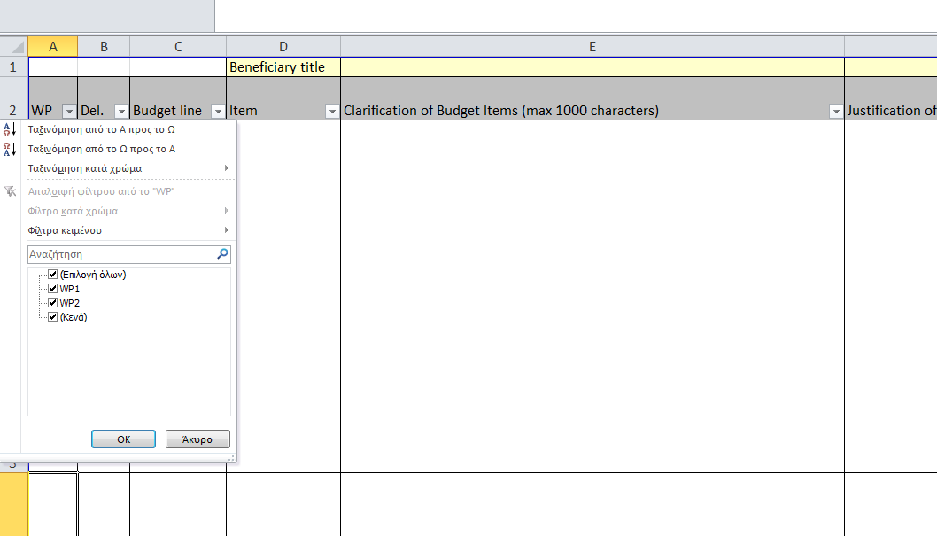
Click on the filter arrow of the WPs column
De-select the (Blanks)

Uploading the SoBC on the MIS
In the framework of the 4rth Call for Project Proposals, the SoBC, completed for the total project budget, must be uploaded in an excel format on the MIS.

